Advanced Game Studies Assignment 2 – Game Design Document

Unlawful Good

(Working Title)

Designed by: Martin Smith, Laura Buttrick, Lawrence Howard, Nathan Darling, Jack James, Arnel Santos and Daniel Dawson

Contents:

1.0 – Synopsis

1.1 – Target Platform and Minimum Hardware Requirements

1.2 – Visual Style

1.3 – Audio Style

2.0 – Game Beginning and Main Menu

2.1 – Introduction, Characters and Narrative

2.2 – HUD

2.3 – Pause and Options

2.4 – Losing the Game

3.0 – Gameplay Introduction

3.1 – Mechanics

3.2 – Score and Currency

3.3 – Player Upgrades

3.4 – Missions

4.0 – Weapons

4.1 – Environment

4.2 - Sounds

*Synopsis:*

The working title for the game is “Unlawful Good”, based on the moral alignment grid present in the adventure game Dungeons and Dragons.

The game is a 3D action game played from a top-down perspective. The player is controlled with both the keyboard and the mouse in a twin-stick shooter kind of fashion. The player takes the role of a female protagonist in an open world that can be explored and interacted with. The game has no defined winning state but is rather played until one of the losing conditions is met with the days survived being the player’s “score”. The player is faced with the challenge of caring for a child and keeping up a household for which money needs to be acquired through committing crimes.

The game has a critical aspect within the crime committing context which is to teach players about the criminal incentives and statistics around the world.

*Target Platform and Minimum Hardware Requirements:*

The game will be built for the PC/Mac. Unity allows the game to be built for Windows and Mac. The game will be developed on windows and so will primarily be aimed at that platform as there may be no access to Macs to test the game works. The game will not be developed for mobiles as the controls will be too difficult to implement in a similar way. The game could be ported to consoles however there is not enough time for this to be completed during the project but may be looked at in the future.

**System requirements**

The systems requirements that the game is expected to require are outlined below. This is however estimation based on the requirements of other unity games with similar graphic styles and open worlds which mean they could change once the game is complete. Some requirements such as hard drive size are left out as it is unknown until the game is complete, however a target of no more than 10 Gigabytes of data should be required for installation.

* OS: Windows Operating System (XP or higher)
* Processor: 2.0 GHz
* Memory: 4 GB RAM
* Graphics: DirectX 9 Compatible. Nvidia Geforce 7800 GT or better.

*Visual Style:*

The visual style of the game is semi-realistic and based on features of a real world Earth during the early years of 2010s, i.e. 2010 – 2013. The style of the game is affected by the chosen player perspective - which is top down, as characters and objects will have a lower poly count than in First Person Shooters for example. To allow for the lower number of polygons to effectively convey the objects and meanings the visual style will use slightly caricature characters i.e. exaggerated features.

As previously mentioned the game world will be based on a real world Earth - the UK to be precise, and as such the colours used will reflect this with the use of dulled colours and grunge. The colour choice was also made to reflect the morose story, dark and sullen with dull colours. The landscapes the player will explore and interactive with are based off UK roads and architecture. As much of the UK is ancient and grown from settlements, the cities of today have winding roads etc. which we will incorporate into our city design. This is also how we will be designing the building architecture, using UK designs with old and new coalescing to form a living city.

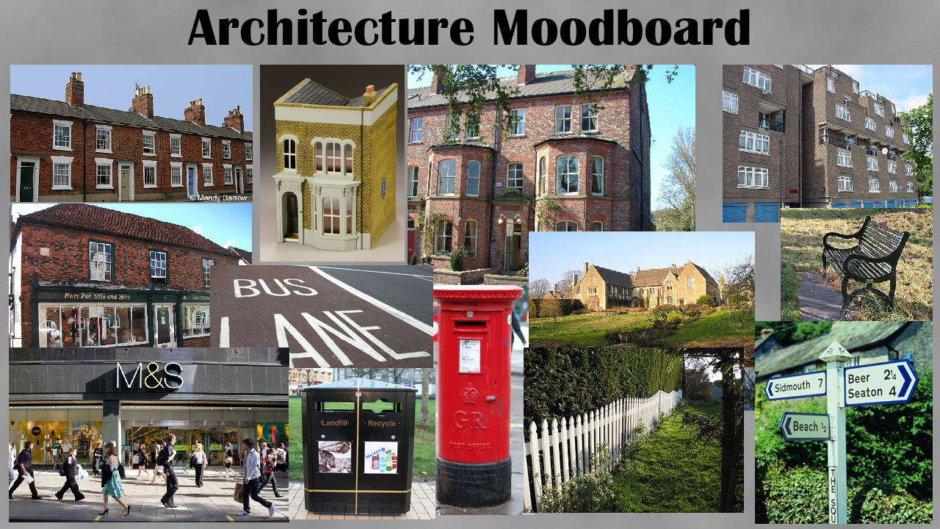

The visual style for the game menus will also follow the same vein as the main game. The use of dull, unsaturated colours will be prevalent in the menu with the text being white to stand out against the dim background. Menu items should be kept simple and interact with the player through the house of hover-highlighting and click-highlighting.

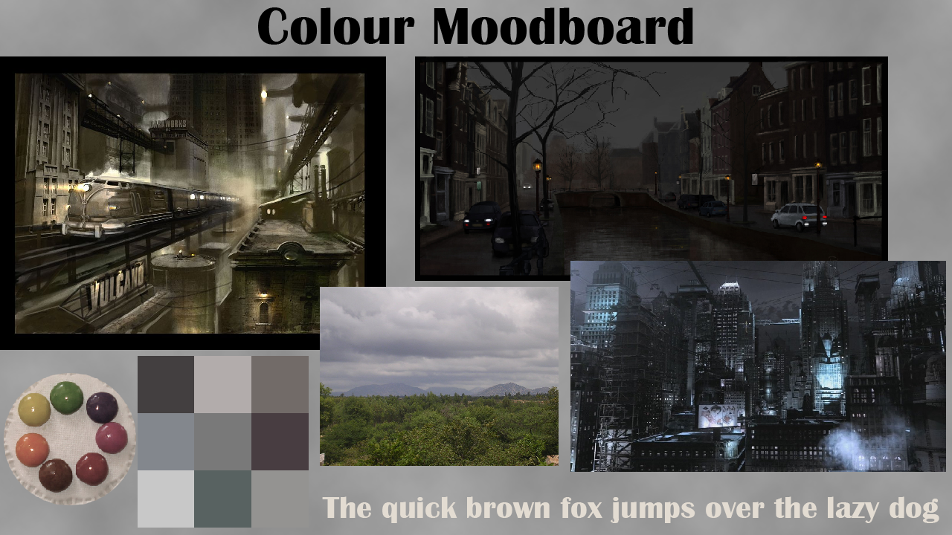

*Audio Style:*

For the environmental sounds real world Foley tracks will be created to represent the different objects, areas, and interactions etc. It is possible for the player to interact with certain other non-player characters within the game but there will be no audio created for these events, just on screen text for the player to read.

Throughout the game there will be background music played which is context dependent e.g. a fast paced song for when the player is being chased by the police or when the player is in the city but there's nothing happening the music will be an ambient track.

In total the game requires 4 different soundtrack. The music that plays during menus, the music that plays at home, the music that plays when roaming the city and music that plays whilst being chased by the police. In all cases to represent he modern setting, the music should take features from modern music inspired by the recent popularity of electronic sounds.

The “Menu Theme” should feature a slow tempo song at low volume. Simple with little instruments but with a catchy melody to make it recognizable.

The “Home Theme” should be similarly slow, a typical slow paced but yet upbeat song with elements of synth to imply a safe and calm place.

The “City Theme” should play only occasionally and be a catchy medium tempo song that complements the mood of the game.

The “Chase Theme” should be a fast paced, exciting song, featuring a dominant drum line to create a sense of danger.

At points at which the player finds herself killing another person, any music should immediately stop and not start again until the player has reached the safe place, home. This is deliberate to give the player room to think about the actions he or she takes within the game.

Menus should feature blips that play upon the mouse hovering over controls and also a chimes that play during menu advancement and return. Furthermore a jingle should play when the player receives a new mail. This should play only at home, complimented with a notification exclamation mark icon next to the e-mail menu button.

*Game Beginning and Main Menu:*

At the beginning of the program, the application should introduce itself with corresponding logos of the developer working on this project, the engine used to make the game as well as any sponsors that might be involved in the creation of this game.

This introduction should not feature any music or simple to no animations to not be obnoxious. Images should fade to the next after 2-3 seconds and inevitably move on to the main menu.

**Main Menu**

The Main Menu will serve as the first focal point for the game, and provides an opportunity to draw the player’s attention to the game before playing it.

The following image demonstrates the layout the Main Menu will take, but not the graphical content. The stock image is representative of a live scene being rendered in the background. This will demonstrate the 3D graphical content and top-down layout of the game.

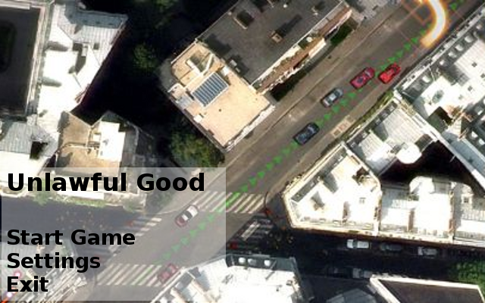

The items on the menu are rendered upon a semi-transparent box, which helps to emphasise the options, instead of losing them in contrast with the background.

The options are detailed as follows:

* **Start Game:** Initialises the main game scene in Unity, this option should be intuitive of any save data.
* **Settings:** This option should update the content of the semi-transparent box to display a few options which the player may change. These may include sound levels, and deleting any saved data.
* **Exit:** This will provide the player with the option to stop the game from running.

*Introduction, Characters and Narrative:*

Game Introduction

You're presented with a splash screen detailing what this game is, what it was made for and who has worked on it. This transitions into the main menu for the game. The player is given the choice to start a new game or load a previous save. There is only one save slot open to the player at any point in the game. If they decide to save over it then they are stuck with the consequences of any changes they made, as is with life. When the player hovers over the New Game option (or any option for that matter) a highlight is placed over it and a sound plays. Screen fades to black. Slowly text appears on screen informing the player of the back story to the game and where they will be when they start the game. The text is as follows;

*"Mina Chancer had a good early life thanks to her parents being wealthy enough to pay for a nice house, clothes, and University education etc. While studying Astrophysics she met the father of her Daughter, Joshua. One thing led to another and - through terrible luck, Mina became pregnant with her daughter Felicia. Unable to find a job after university and being a single parent (Joshua moved back home after University but before Felicia was born), Mina struggled with the health of her only child as Felicia was diagnosed with Cystic Fibrosis. To make matters worse the current economic climate had a great impact on her parents leaving them unable to help with their daughter and grand-daughter. Over the years Mina has taken out many loans and credit cards to try cover the cost of living and the specialist treatment her daughter requires, but is currently unable to attain any more funds."*

Cut to Mina and Felicia at home. The day is half gone and Felicia is back from school. With the money initialized at -£250 Mina really needs to get a stable income capable of supporting herself and her daughter. She has no equipment to speak of and no upgrades, both of which are introduced later in the game. A conversation between Mina and Felicia occurs:

Mina: "Ok dear, I'm going to town for a little while to hand some CVs out. Make sure you don't answer the door and ring 999 if you need any help."

Felicia: "Ok Mum, don't be too long. And can I have some chocolate while you're out please?"

Mina: "We'll see if you've been a good girl when I get back."

Mina steps out into the city, a top down perspective camera is used, centered on Mina. The player is moved to the car where they are then given control. The player can drive around town and - when near a shop, can go inside to hand a CV to the owner. A conversation between the player and the shop owner will occur:

Mina: "Hi, I was just wondering if you're looking for anyone to help run the shop."

Owner: "Sorry Love, I'm barely making enough to pay myself as it is."

Mina: "Could you at least take a CV and keep it on file? Thanks."

Mina hands the CV over, leaves the shop and enters her car again. The same situation occurs in each shop she applies for, they can't take her on. The dialogue she has with the shop owners is there to inform the player about the terrible economic situation alongside the comment on her parent’s finances in the intro text. After the first day and on the morning of the second day Mina receives an email from the Bank Manager whom oversees her loans. The email reads as follows;

*"Dear Mrs. Chancer,*

*As I'm sure you know I've taken it upon myself to review the loans you've had with us in the past, as well as those not through us. I don't think I can overstate that your current situation is dire indeed but I believe I can help you. If you would be so kind as to meet me at the bank within the hour I'd be delighted to talk through this opportunity with you and hopefully get you back on the right track.*

*Yours sincerely, Mr. W. Anchor"*

The player is then guided to the bank where she is taken to the meeting with Mr. W. Anchor the bank manager and a conversation occurs:

Mr. Anchor: "Ah Mrs. Chancer, glad you made it. Let's get straight to business. I have a little offer for you, I'm a powerful man and I'm willing to teach you about how you can make money to look after your kid as well as keep me happy.”

Mina: "Go on, what're you thinking?"

Mr. Anchor: "Well, because of my position I'm privy to a lot of information such as how certain people turn to petty crime to fund themselves when times are hard."

Mina: "What? I've never done anything like that. I care for what you're insinuating."

Mr. Anchor: "Now, now. I wasn't insinuating anything. No more beating around the bush. I will teach you what I've learned of petty crime from the various clients that have walked in here, I'll even give you the tools you need. All you have to do is go mug someone on the street and we split it."

Mina: "I, I don't know. I've been trying to look for a job. Trying to get it all sorted out."

Mr. Anchor: "Well it's entirely up to you of course but I'm sure you know you're not currently in the bank's good books. Just remember what I said."

Mina is gestured to the door, she stands and leaves. It is entirely up to the player what they then do. They are free to go around town giving CVs to shops forever or they can mug someone and progress through the story.

**Characters**

Mina Chancer

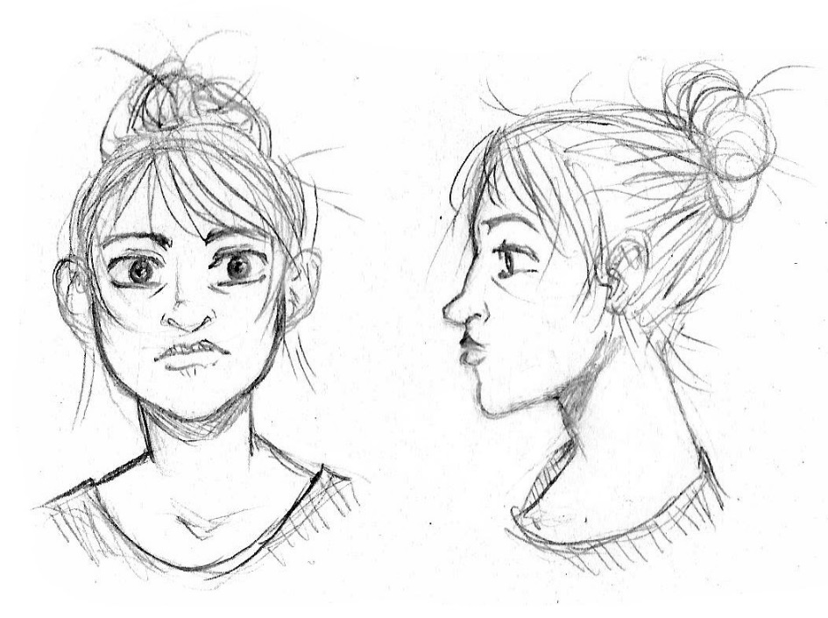

The main character and protagonist of the game. Mina grew up in a well-off family who were able to fund her years at university, enabling her to achieve a 2:1 Hons in Physics with Astrophysics. However, the recent economic climate has seen both her parents made redundant, limiting the assistance they can give her, and government cuts mean that their previous income have rendered her ineligible for welfare support despite being an independent claimant. While her degree is a good one, employers are deluged with applicants and would rather take on free labour from the government’s Welfare to Work scheme than pay a qualified graduate. Her attempts to enter academia have been hampered by further funding cuts and rampant nepotism within the astrophysics field.

Mina met her daughter’s father, Joshua, when she was in her final year of university. Due to her contraceptive implant being incorrectly inserted by an untrained nurse, Mina fell pregnant. After graduation, Joshua moved back home to Grantham and sent Mina a text saying he didn’t think things were going to work long distance, and promptly dropped all further contact. Mina gave birth to Felicia four months after graduating.

To support herself, Mina took out multiple credit cards and even a bank loan to pay off rent and food bills. Once Felicia was born it was revealed that she was suffering from cystic fibrosis, a lifelong, incurable illness affecting the lungs. Further debts mounted up as Mina tried to pay for her care requirements at home, with NHS waiting lists for equipment months or even years long – waiting lists longer than the life expectancy of her only child. Now, with her credit cards maxed and the last of the loan spent, the money that Mina brings home is not enough to cover both Felicia’s care needs and the debt she must pay off each month.

Felicia Chancer

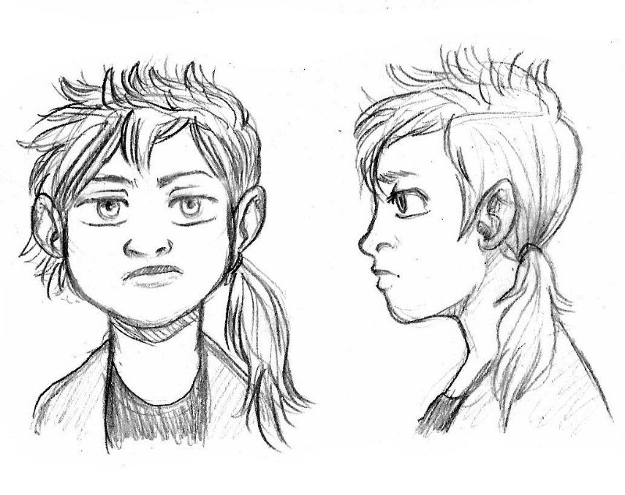

Felicia is a bright young child despite the unfortunate conditions into which she had been born, but she is ailing fast without access to proper medical care. She is lonely due to isolation at school and whenever her mother is at work she grows lonelier. She spends a lot of time off of school due to complications with her illness and is swiftly falling behind in her classes. She enjoys reading and often takes out stacks of books from the library to pass the time; however, when she accrues fines, it falls to her mother to pay them. Felicia has a life expectancy of thirty one years, but she looks unlikely to reach seventeen unless her life dramatically turns around.

William Anchor

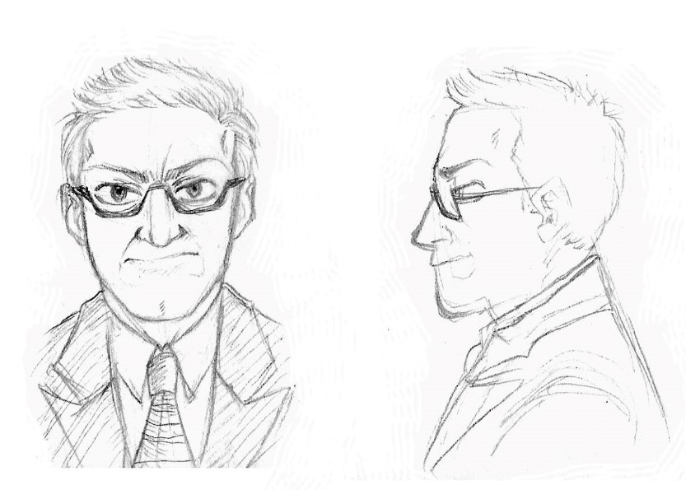

William is the chief executive banker at Berkley’s bank, and holds the majority of Mina’s debts in his portfolio. He has had several meetings with Mina regarding the amount owed and her late payments, and considers himself to be a sympathetic and kind man. Knowing that Mina’s child is ill, he offers her the opportunity to make some extra money running errands for him around the city.

**Narrative**

The story begins with Mina already in debt and Felicia very unwell. Mina is contacted by William Anchor, her banker, who offers her a job in exchange for writing off some of her debt. This means that Mina can spend the income from her call centre job on Felicia. William tells her what the job is, and she is alarmed to hear she is required to retrieve owed money from another client of Berkley’s through any means she deems necessary. Mina can decline the work, but it would mean that Felicia will fall gravely ill.

The narrative is further dictated by the player’s decisions; choosing to run errands for William, and performing them successfully, will mean enough money to support Felicia, but they come with the added risk of being caught by the police and having Felicia taken away into care (resulting in a Game Over). Additionally, each errand performed results in Mina being delivered a profile of the affected target after the event, wherein she learns of their histories and reasons for falling on the wrong side of William. It becomes clear that she could easily fall on William’s “wrong” side as well, as his instructions become more insidious.

Wybertown

Wybertown was originally a market trader town, grown out of a river settlement (the river Wyber still winds through the city to this day). It achieved city status when the Cathedral was completed in the early twelfth century, though has only recently acquired its own university (ranked 89th in the UK). Wybertown has a reputation for its unusually windy roads and archaic city centre – the newest shop was a Woolworths that opened in the 1980s and closed in the mid 2000s. Locally owned shops do not so much thrive as survive, with no major commercial retailers interested in purchasing retail space in Wybertown’s empty shop fronts. With an average unemployment rate of 7%, nearly triple the national average, Wybertown is witness to some of the worst of the economic downturn, though rents are delightfully cheap.

Wybertown is divided roughly into three districts, with affluence determined by proximity to the city centre. Houses closest to the city centre are generally occupied by more impoverished tenants; despite popular trends of city centre rents being higher, in Wybertown they buck this trend due to the low quality of the housing offered. The further a habitation is from the city centre, generally speaking, the higher the income of those who live there (contributing to the popular local joke “The further you get from Wybertown, the richer you become!”)

*Heads Up Display (HUD):*

The HUD serves as the player’s primary source of live game information. It should provide an easily readable overview of the basic game state, and inform them of any important factors in the game world. The HUD should be intuitive, but not intrusive, so as not to congest the 3D environment. Simple, yet informative.

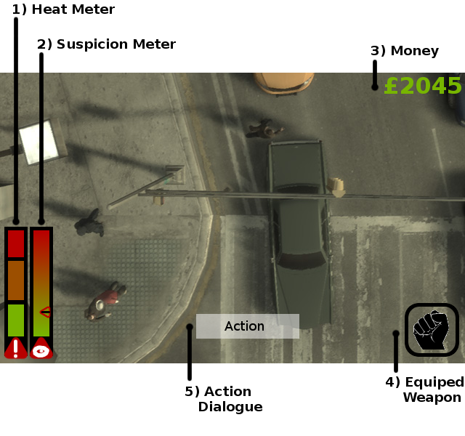

**1: Heat Meter**

The Heat Meter (HM) in *Unlawful Good* represents the level of vigilance of the local police officers (see mechanics).

The GUI should incorporate three bars, which range from low (green), medium (orange), and high (red). These levels should display full colour to indicate the level of Heat from the officers in the currently occupied area of the city that the player is in.

When an indicator is not in use, it should display as a washed out version of its representative colour.

The bar has been assigned a red icon, with a white exclamation mark. This will quickly enable the player to associate this bar with Heat, following an on screen prompt or in-game tutorial.

It has been placed in the lower left hand corner of the screen, in a horizontal fashion. This should help to reduce on screen congestion, whilst allowing it to be coupled with extra bars that correspond to in-area police information.

The bar should automatically update when the player moves from one area to another.

**2: Suspicion Meter**

The Suspicion Meter (SM) in *Unlawful Good* represents the level of interest the police officers in the game world are currently showing towards the player. It will affect the response times of local officers (see mechanics).

The bar comprises of a green to red gradient, and an arrow indicator which displays the current level of suspicion. This indicator should slide up and down depending on the player’s actions.

The bar has been assigned a red icon, with a white eye. This will quickly enable the player to associate this bar with Suspicion, following an on screen prompt or in-game tutorial.

It has been placed in the lower left hand corner of the screen, in a horizontal fashion. This should help to reduce on screen congestion, whilst allowing it to be coupled with extra bars that correspond to in-area police information.

The bar should automatically update whenever the player performs any action that would increase or decrease the suspicion level in that area.

**3: Money**

The amount of money the player is in possession of is displayed in the upper right section of the screen.

The amount is displayed in green, and preceded with a sterling-symbol. Green is a colour which is often used to represent money. The player should quickly associate these two facts.

This value should adjust automatically based on the player’s actions.

**4: Equipped Weapon**

This icon provides the player with a visual prompt as to their currently held weapon.

This icon should update automatically as the player scrolls through their weapons, or equips a new one.

The icon is given a transparent background in order to reduce on-screen congestion.

The icon is colour-neutral, and each weapon icon should retain to an intuitive and readable visual prompt only.

**5: Action Dialogue**

This prompt appears whenever the player may perform an action. This will notify the player what that action is, and what button to press to trigger the action.

The white semi-transparent box ensures the text is always readable, no matter how dark the background is. The semi-transparency reduces screen congestion.

*Pause and Options:*

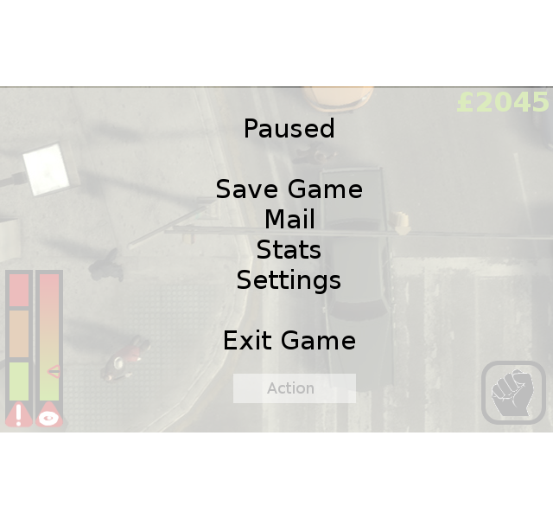

The pause menu simply pauses all Update logic calls within non-menu GameObjects, and overlays the screen with a semi-transparent white background. This allows players to glimpse where they are before returning to play. It ensures a certain level of readiness when returning. The pause menu provides access to several systems, such as Mail, Stats, and Exiting. The systems are listed in a simple centre-aligned layout, as is common in many other games. The centre becomes the focal point.

The screen quite helpfully points out that the game is indeed paused, just so the player isn’t concerned!

This screen should be closed once the player presses the same button he/she used to open it. The screen could also benefit from a ‘Return to Game’ option.

This design should also extend to options. Centre aligned with bold headings for an ‘option’, and non-bold text for ‘value’ (such as on or off). In order to quicken development, fancy graphical representations, such as sliders, can be forsaken for text values only.

E-Mail

The email system provides the player with an overview of missions, and acts the objective tracker for the game. The player will be prompted through a series of emails to progress through the game.

The email system will be represented by a simplified email client, similar to that of Microsoft’s Web Outlook tool.

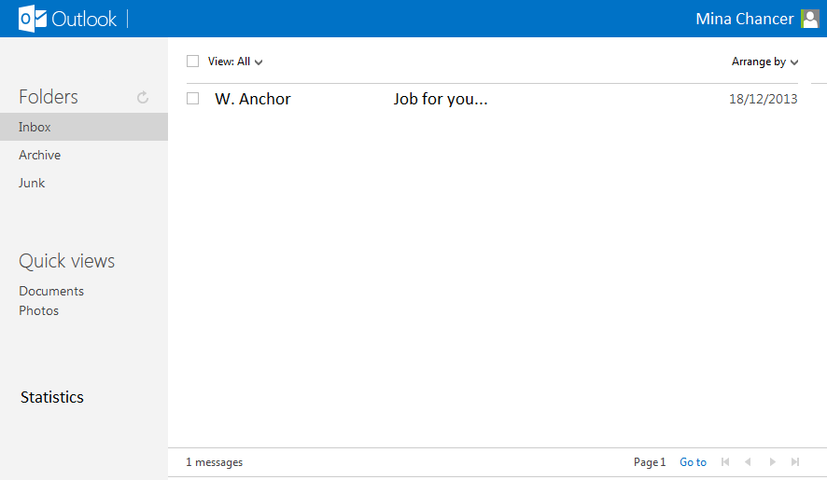

The email system should provide a folder view of all incoming emails; this allows the player to focus on mission objectives, whilst reading the spam/junk emails on their own initiative.

Many of the expect features, such as arranging emails by date, are not required for this system.

Emails should be displayed in chronological order, with the newest emails displayed at the top of the page, and the oldest at the bottom.

Emails will be stored in a text file, and released to the player once certain conditions are met (usually upon completion of the objectives of the previous emails).

Statistics

Player statistics will provide an overview of actions the player has performed, and time spent in the game. It will also provide a summary of financial occurrences.

For ease of access, and to cut development time, this system can be integrated into the mail system.

Statistics should be displayed in a very simple text format.

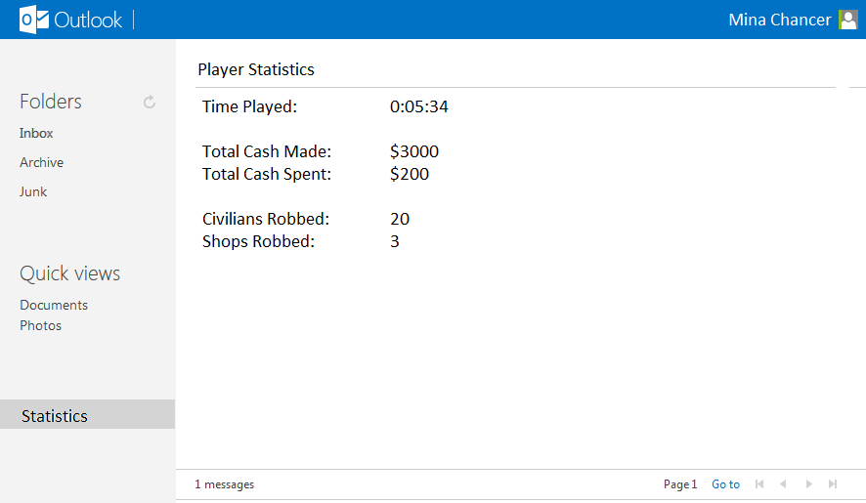

*Losing the Game*

There are no winning conditions within the game as the player basically plays whilst the player can sustain the character. There are 3 ways to lose the game however; your house is repossessed due to your debt, your child is taken away from you or you are arrested. The game over screens should feature a still image with large text to represent the losing condition met and should also feature a button to start over and one to exit the game.

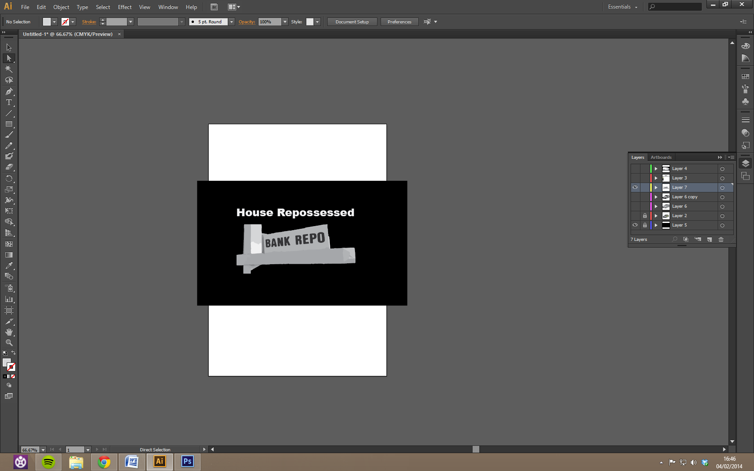

Sample Game-Over Screen 1: House Repossessed

One way in which the player can lose the game is by getting into too much debt and having their house taken away. The player starts the game with debt and lowers this debt by completing jobs for the banker. If the player chooses to do things other than jobs for the banker such as spending time with their child their debt will begin to creep up. If the player continually does this the debt will continue to rise until it becomes too much and they lose their house, ending the game. The player can stop the increase of debt by doing jobs for the banker in order to earn money. The game over screen should look similar to the sample screens above with a message telling the player why they have failed and an image related to it such as the repo sign.

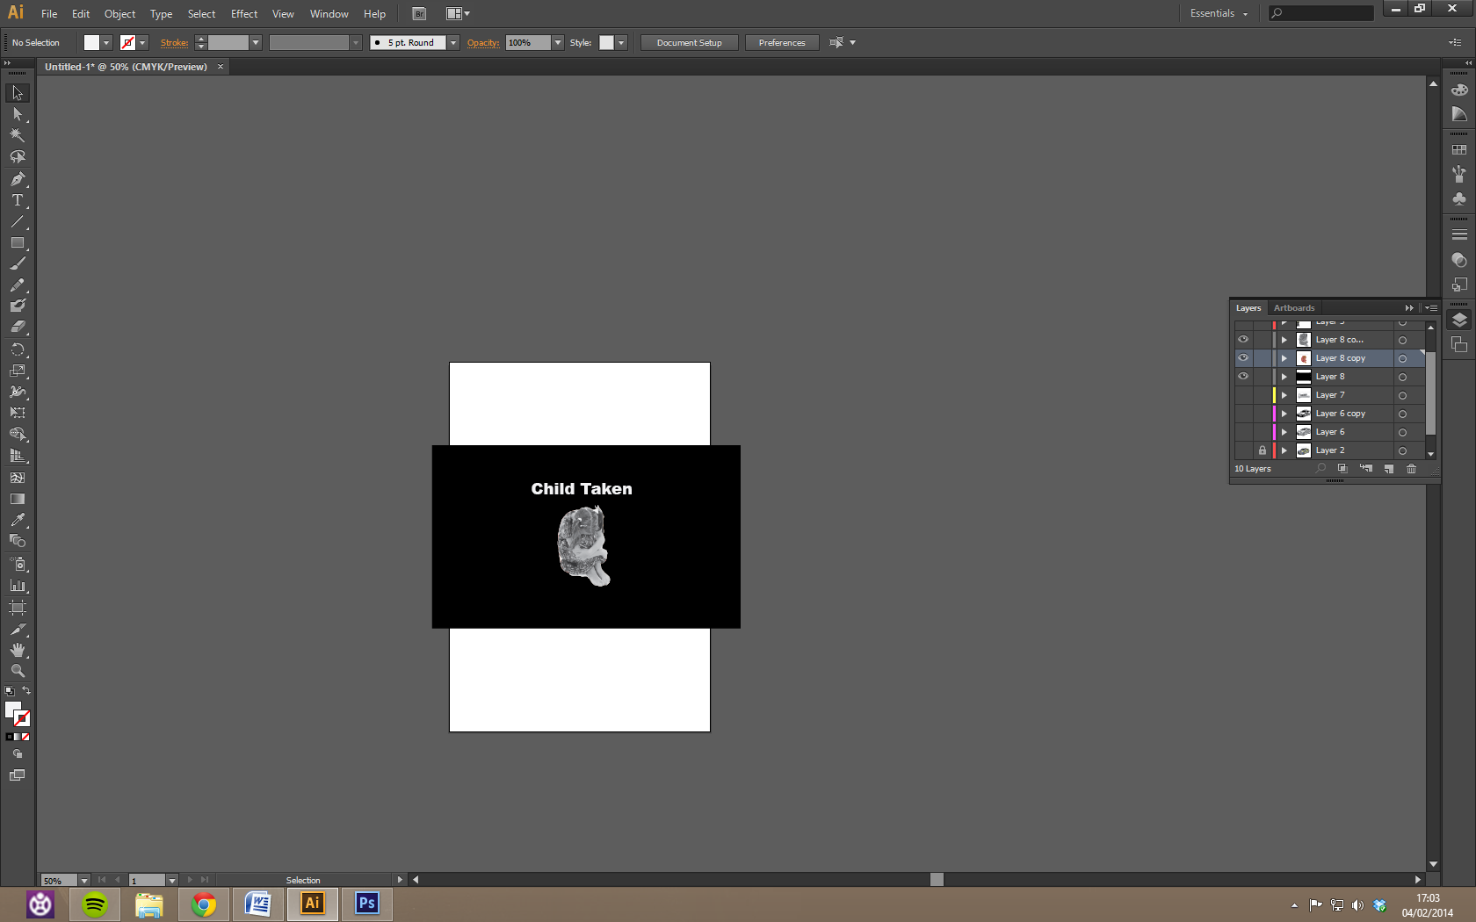

Sample Game-Over Screen 2: Child Taken Away

The second way in which the player can lose the game is by having their child taken away. The player has a child in the game and they have to spend time with that child in order to make sure the child is okay and happy. If the player spends too much time doing jobs for the banker or doing things other than spending time with the child the child’s happiness will go down. Repeatedly not spending some of the time slots with the child will result in the child’s happiness reaching 0 and social services will step in taking the child away, ending the game. The player can stop this happening by spending some of their time slots on the child and giving them what they want when random events of the child asking for something occur. The game over screen for this should be a message about why the player failed and an image of a sad child or a child being carried away such as the samples.

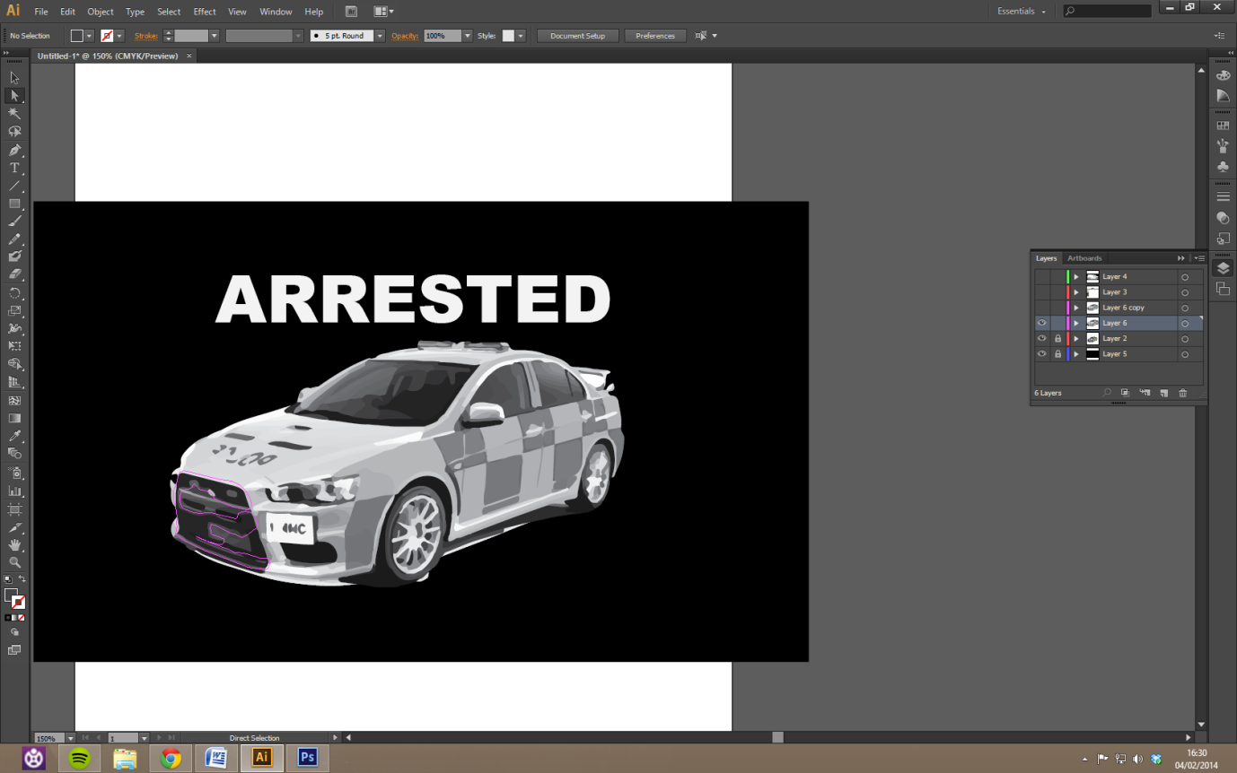

Sample Game-Over Screen 3: Arrested

The third and final way the player can fail is to be arrested. Since the jobs the player is doing are illegal they have to be careful not to be caught by the police. Each job the player does increases the heat and suspicion of the police. The heat level of the police effects how fast the police will respond and if the player is caught at the crime by police the game will end with an arrest. Each job the player does will also increase the suspicion of the police. If the suspicion gets too high the police will come and arrest the player, ending the game even if the player was not caught at the scene of the crime. The player can lower the suspicion of the police by spending time doing other things such as seeing their child. If the player is arrested the game over screen should be a message about why the player failed and an image of a police car or officer such as the samples.

Even though there are three ways to fail they are all essentially because of the same thing; spending too much time on one activity.

* Spending too much time with the child will decrease suspicion and make the child happy but eventually the debt will mean the house is taken.
* Spending too much time not seeing the child will end with the child being taken away
* Spending too much time on jobs will mean the debt is not too high and you will have money to treat your child but the police will arrest you.

In order for the player to succeed in this game they have to balance their time slots, ensuring they are doing enough jobs to keep the debt low while spending time with their child in order to keep them happy and decrease suspicion.

*Game Introduction*

An introduction to the gameplay and its mechanics is best broken up into several sections that can be explained further. The main features of the game are:

* Top-down Character Controls
* Open World
* A List of Different Crimes
* Random Pedestrians and Vehicles
* Random Player Events
* Child and Home Interaction
* Police Suspicion and Heat
* Time Management

**Top-down Character Controls**

The gameplay should be similar to that in the original Grand Theft Auto games developed by DMA Design. Using the Unity 3D engine, the game will feature full 3D graphics and a twin-stick shooter kind of control scheme.

Controls

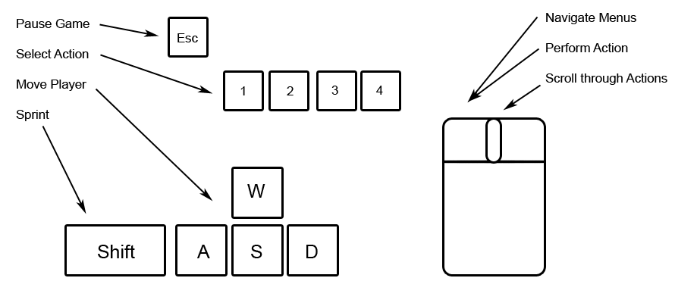

Proposed Controls for the Game

The player will interact with the various menu interfaces using the mouse and once in “free roam” mode the player can move using the “WASD” buttons and interacting with people by pointing and clicking. The player’s action can be switched with the mouse wheel between Talk, Pickpocket, Use Weapon and Pick Lock.

Gameplay can be paused at any time using the Esc key in where the player can exit the game immediately. The player may also sprint using the shift key during which it cannot perform any actions.

**Open World**

The game is played in a fictional city named “Wybertown”. The city as described in the narrative part has a plethora of economic and social problems and is therefore a perfect setting for crimes. The City is split up in 3 different districts. The Upper-Class district, known for its well-kept streets and financially stable shops, the high street district which features many different shops and services for the people of Wybertown, and the Lower-class district, the home district of the protagonist which is a financially unstable district which finds itself in a rather bad state.

The district are connected with a single main road that the player can travel on either by car or by foot. Within the different district the player will find many houses which are purely there for cosmetic purposes but also the odd shop and a stray pedestrian that the player may interact with.

A map of the city with important buildings marked out is available in the “Environment” section of this Game Design Document.

The city is largely influenced by British design and architecture during the early years of 2010’s and will therefore feature British road signs and other typical British street decorations. The currency in the fictional world is simply called “Monies” and uses the Pound symbol (£). Names of places and people in the game are completely fictional and do not represent the opinions of any real world characters.

**A List of Different Crimes**

The game focuses on the criminal habits of the protagonist and due to moral reasons leaves the child out of any criminal activities. The player has a choice of a number of different crimes which are chosen from a list of most popular crimes in the UK. In order of frequency, the 5 types of crimes that were committed over the cause of a year between 2012 and 2013 in the UK are as follows

1. Theft and Handling Stolen Goods
2. Violence against the Person
3. Criminal Damage
4. Burglary
5. Drug Offences

The 3 crimes that the game will feature as the main source of income for the player are Theft, Burglary and Robberies which are committed on randomly spawned pedestrians or in the number of different stores dotted around the map.

**Random Pedestrians and Vehicles**

The city will be kept interesting and alive through the use of vehicles and pedestrians which are spawned randomly as the player moves through the streets. The pedestrians will not talk or otherwise perform actions other than moving from one point to another but can be interacted with when the player presents a weapon, resulting in the pedestrian either running away or giving up his belongings which implies a successful mugging.

A couple of different vehicles will be featured that drive around town. These cannot be hijacked on the move unless the player has a gun, as it is safe to assume that a sane pedestrian is able to lock his door and simply drive away. Vehicles that have spawned in parking lots however can be broken into to retrieve goods or with sufficient skill can be hotwired to be driven away and pawned at a fence.

**Random Player Events**

The player may be confronted with random events at the beginning of the day which can be dealt with through multiple choices. An example of such an event would be the child asking for a treat of some sorts, which will put the player in more financial troubles but keeps the child’s happiness level above 0.

**Child and Home Interaction**

There are a few things the player can do at home without the need of going outside. The player can spend a precious time slot to interact with the kid, increasing the happiness of the child whilst also decreasing the suspicion of the police. There are also a couple of actions the player can perform without losing time such as checking the email system and the player’s statistics.

The child’s mood plays an important factor in the game as losing the child will count as a failure and end the game. The child can be “lost” if the mood reaches below a certain threshold for too long. Depending on what the last few interactions with the child were the child will be lost either by being arrested by the police or taken by social workers for not being able to provide for the child’s needs.

Not allowing the child the things it wants will lower the mood, as will staying out for too long when performing crime and not spending time with the child.

When the player successfully finishes a mission set out by the banker, a mail will be received giving a profile of the targets criminal career. The mail should be based on real world scenarios in which a person has fallen into criminality to teach about the causes of crime.

Every so often the player will also receive a “newsletter” with statistics and random facts about crimes across the UK, which are again, based of real-world statistics.

Email

The email system provides the player with an overview of missions, and acts the objective tracker for the game. The player will be prompted through a series of emails to progress through the game.

The email system will be represented by a simplified email client, similar to that of Microsoft’s Web Outlook tool.



The email system should provide a folder view of all incoming emails; this allows the player to focus on mission objectives, whilst reading the spam/junk emails on their own initiative.

Many of the expect features, such as arranging emails by date, are not required for this system.

Emails should be displayed in chronological order, with the newest emails displayed at the top of the page, and the oldest at the bottom.

Emails will be stored in a text file, and released to the player once certain conditions are met (usually upon completion of the objectives of the previous emails).

Statistics

Player statistics will provide an overview of actions the player has performed, and time spent in the game. It will also provide a summary of financial occurrences.

For ease of access, and to cut development time, this system can be integrated into the mail system.

Statistics should be displayed in a very simple text format.



**Police Suspicion and Heat**

As the player progressively commits more crime, the Wybertown police will become ever more aware of the increase of crimes. There are 2 factors which determine the speed of police catching on to the player’s crime:

Police suspicion is a statistic that determines how likely the player is to get caught by the police. When the police suspicion reaches 100, the player will get a visit from the police arresting the player.

A higher suspicion also means that heat is acquired sooner. There are 3 heat numbers, one for each of the city’s districts. The heat has a higher base value in the high street district and an even higher base value in the upper-class district and is increased whenever a crime is performed in that district.

The heat level determines how quickly police react to a crime. A lower heat levels means the player has more time to get away from the police. Heat decreases with every passing time slot and decreases faster when suspicion is low.

**Time Management**

The player has 4 time slots to use up per day. The day ends when all time slots have been used up through different actions. After 7 days have been played the player is given a summary of weekly incomes and expenses detailing exactly how much the player needs to earn in order to upkeep with the expenses of living.

Day + 1

Action

See status

Read Mail

Go Outside

See Kid

Only in time slot 3 or 4

Use Time

Random Event

All 4 Time Slots Used

Time Slots Left

End of Week

Weekly Summary

*Mechanics:*

The goal of the game is to maintain your freedom, child and house despite not having enough income to pay off your mortgage and no hopes of finding a job. To do this the player must earn money the only way they can, by committing various crimes such as theft and shoplifting while still being able to fulfil your duties as a parent.

**Day Cycle**

During each In-game day the player initially starts off at home seeing the home menu screen and is able to explore the town freely and perform one of several actions.

• Stay in the house: The house is a menu which allows players to read their mail, check statistics, hide from the police or interact with the child.

• Check mail: Look at mail you have received. This mail includes facts related to crimes the players has committed, general information on crime and poverty statistics and a reminder of topics brought up in the tutorial.

• Spend time with Felicia: Spend some time with Felicia in order to bond and keep her happy. This raises child happiness but costs time. This action can only be performed in the later 2 time slots as otherwise Felicia is at school.

• Rest: Skip ahead a time slot whilst staying at home. This is the default selected option and will reduce police heat to the initial values and slightly reduce police suspicion too.

• Save: This option will save the game. Additionally, the game also auto-save every week after the end of day 7 when the player is shown the weekly summary.

• Look for a job: There aren't any jobs to find, but the player can choose to go into stores and ask. This uses up time and effectively gives the player a sense of hope where there is none.

• Commit petty crime: As the standard way to make money the meat of the game is in petty crime: To commit petty crime all the player needs to do is perform one of the following specified actions:

Mugging: By equipping a weapon and holding the “use” button while facing a pedestrian at point blank you will attempt to mug them. Depending on the pedestrian type it will take different amounts of time to mug someone (a big guy will take longer than an Old Lady) but some harder targets give up more cash. Cash gained also increases in the upper class and high street districts. Strong targets may also try to run if you use the knife, but won't run from a gun. However regardless of weapon a policeman will instantly arrest Mina is she attempts to mug him. If you are seen mugging(sightlines are shown while you have a weapon equipped) the police will be called immediately the alert state will move to searching and the police will start moving towards the player’s location. The police will also be called if the mugging is interrupted and not re-established within 5 seconds. The victim cannot call the police after being successfully mugged as the player just took their phone. If the player successfully mugs without alerting the police then time will pass, otherwise time will pass once the police are evaded. The multipliers per district are *1.5 in rich, *1 in city and *0.5 in poor.

|  |  |  |  |
| --- | --- | --- | --- |
| Type of Pedestrian | Time-to-Mug | Chance to flee a Knife | Base Money Given |
| Burly/tough man | 15 seconds | 33% | £20 |
| Normal man | 10 seconds | 15% | £25 |
| Old man | 7 seconds | 0% | £12 |
| Fit woman | 12 seconds | 20% | £20 |
| Normal woman | 9 seconds | 5% | £18 |
| Old woman | 5 seconds | 0% | £16 |

Shoplifting: by entering a store with no security (such as a corner shop) and pressing the action key next to a shelf you can start the shoplifting mini-game. Once the mini-game is started the sightlines for everyone in the shop appear and the action key becomes “take” when next to an item that would normally be bought such as food or toiletries. Holding the action key for a second at this point will cause Mina to grab the item and put in her bag, but if someone is watching at the end of the animation then the store will be alerted. There is no penalty for cancelling the animation by letting go or for leaving the store, but a time slot will be used the moment an item is taken. If the player is caught than the police are called and if a policeman makes it to the shop door while the player is still in the shop they are caught automatically (as there’s no escape for the player). After 3 items are taken, or the player leaves the store and confirms so with a prompt, time is used up. Depending on the value of item taken and the district modifier of the store, the player can earn around £80.

Armed Robbery: In the store, instead of selecting a shelf the player can select the cashier with a weapon equipped and hold him up. This instantly pays 30*(number of available shoplifts remaining)* district modifier and calls the police. In order to avoid accidents the player can look outside the window to check for cops at any time.

Car Jacking: The player can attempt to enter a vehicle they don’t own by hold the use key next to a car that is driving, this will require a gun. The player must then mash the use key X times before the car reaches Y speed in order to steal it (X and Y to be decided in testing). Regardless of success the police are called and the player has to evade them. Stolen cars can either be left along the roads to reduce police heat but does not give the player any cash, alternatively the play may bring the car to the banker’s fence where the car can be pawned for money depending on the quality of the car. This is not affected by the district modifier.

Car theft: The same as car-jacking but the player takes a stopped car. To initiate car-jacking the player must go up to a car and hold the action button for a second to break in. This will require the car theft upgrade available from the banker. this triggers the alarm and will result in the police being called if someone enters audio range. After 10 seconds of stealing the car the car will be drivable if the player has the hotwire upgrade. This action can abandoned at any time but the police will still be in pursuit. Breaking into a car causes the player the retrieve any valuables, earning a random amount of money between £10 and £150.

The player can also contact the banker for a mission, these missions are more difficult/risky then petty crime but pay much better. The player can also choose to buy a deactivated pistol for £300, though random people won't know it's deactivated so it can be used for safer muggings.

**Police Alert System**

Whenever someone calls the police on Mina the police are put onto alert using the police alert system. There are 3 levels of police alert:

* None: The police are not pursuing Mina and will not arrest or approach her. Ends when the police are called or the victim of a crime.
* Searching: the police are looking to arrest Mina, but don’t know exactly where she is. The police will go to her last known location and then fan out randomly like normal traffic to search the area. If they spot Mina then they will move to the pursuit status. You can only leave searching by using time at home.
* Pursuit: If the police know where Mina is they will enter pursuit. And home in on her position. If they catch her they will arrest her and it is game over. This status will downgrade to searching if the police lose sight of Mina for 10 seconds.

**End of Week**

At the end of the week all the money earned is added up and compared to the amount of debt, food and bills to see if Mina survives the week. The total amount of weekly expenditure comes up to £1100 after benefits at first, however each week inflation causes this amount to increase by £10 in order to increase the difficulty of the game. The amount of money the player has initially is -£250, and this can go down to -£25000 before the repossession end-game is met.

**Caring For the Child**

Each day, during the latter 2 time-slots you may choose to watch the child instead of performing crime. Each day the child loses 10 happiness naturally, + one additional happiness for each previous day without contact with Mina. When happiness reaches zero the child gets into trouble/runs away/otherwise gets taken by social services and its game over. Spending time with the child restores happiness by 12.

**Police Presence**

The amount of police on the street is determined by how many crimes have been performed in that district recently and in that specific time-slot. Presence goes up by 1 whenever a crime is committed in that area without the police being called, 2 if the police are called. This amount is doubled for car theft/hijacking and multiplied by 1.5 for the rich district and 0.75 for the poor one. Additionally 1/10th of the presence is added to the same time-slot in other districts and the same districts in other time slots.

Additionally if a car is seen being used for a crime (which is to say the police saw the player in it during pursuit mode) then the car will gain a wanted point as unlike Mina the car cannot change clothes and hairstyle to dodge the cops (this happens implicitly and automatically). If the police see a car in use with 3 or more wanted points they will enter pursuit mode.

**The Open World**

Within the world there are several features to facilitate gameplay. Pedestrians and cars are generated off-screen at places called nodes, these nodes are typically placed at junctions within whatever lane the NPC is spawning in. once created the NPC's will choose an adjacent node and travel to it following traffic laws and conventions, then they choose a new adjacent node (other than the one they just came from) and move to it. Pedestrian type is randomly chosen on creation, but the police will spawn more if the presence for that district and time is high.

If for whatever reason Mina becomes injured (such as being run over) the day automatically ends, but if at least 1 timeslot remains after the current one it counts as a single child visit (regardless of remaining time).

**Tutorial Week**

The first week of the game is a tutorial which teaches the player how to play and establishes the story. This is somewhat more scripted then regular gameplay but can be skipped with a menu option before the games start, however the player cannot lose for the duration, doing so just restarts the current goal. This is what happens on each day.

The first day starts at time segment 3, and introduces the player to the mail system that contains a warning that Mina is being watched by social services and the bank due to her continuing poverty as well as the money and happiness system.

On day 2 they get a mail telling them of a meeting at the bank to discuss paying off the debts. And the player may choose to follow up on that or to stay at home.

The next days, up until the end of the week the player is free to play as he or she chooses but should receive at least one mission from the banker to introduce the idea of that.

The player is also introduced to the weekly bill this week, though the events of the week cause the player to break even.

**Random Events**

At the start of each day there is the possibility of a random event. These events are generated at the start of the day and are typically negative, but can be positive. The chance of a random event being generated is 10% after which another RNG is done to signal what event happens. The chance of an event occurring increases by 10% for each day where no event occurred and resets back to 10% when an event has occurred. The following is a list of events that may occur during the game:

|  |  |  |
| --- | --- | --- |
| Event | Options | Effect |
| Felicia is ill. Lasts for 4 days and allows the player to spend time with the child all day. | Spend Time (Any Time Slot)  Leave Alone | Usual effects of spending time with child.  -5 Happiness |
| Felicia loses her coat. In effect until a new coat is bought. | Buy New Coat  Leave Alone | Pay £100  -2 Happiness, 10% chance of Felicia falling ill for every day without coat. |
| Felicia wants a treat. | Buy Treat  Ignore | Pay random amount between £10 and £200. +10 Happiness.  -5 Happiness |
| Car breaks down. In effect until the car is repaired. | Repair Car  Ignore | Pay Random amount between £250 and £1000.  Nothing |
| The heating/ fridge/ freezer/ cooker/ computer/ TV breaks down. In effect until fixed. | Repair broken item  Ignore | Pay Random amount between £50 and £300.  -3 Happiness |
| A relative sends you a care package. | None | Receive £50 |
| You've been burgled. | None | -£300, -20 happiness |
| Felicia is staying at friends today. | None | Cannot interact with the child. |
| Felicia wants to have friends over. | Allow  Disallow | +15 happiness, can't spend time, -£10  -5 Happiness |
| Felicia needs new clothes. | Allow  Disallow | -£150  -3 Happiness, next event will cost £20 more. |

*Score and Currency:*

The players score is simply how many days they manage to survive. The player earns money during the game by completing missions for the banker as well as mini missions such as shoplifting. The money can be used in a number of ways; however it is used primarily to lower the debt the player is in. It can also be used to treat their child to keep them happy, buy weapons for use on missions and buy player upgrades. It is important for the player to balance their money in order to keep surviving thus getting a higher score. Money is treated as a single value for this game. There is no distinction between money that finds itself in the bank, or in the player’s pockets.

*Player Upgrades:*

There will be two upgrades the player can get throughout the game. Breaking into cars and hotwiring cars. These will allow the player to move around the city faster and will help them avoid the police. The upgrades will be learned from the banker if the player choses to do so after the first week for breaking into cars and the second week for hotwiring them.

*Missions:*

The banker will give the player missions via the mail system. Before a mission is started the player will receive an email such as:

*“I’m owed a lot of money by a certain individual. Unfortunately I need this money now and he seems to have disappeared. His car should cover his debt. It’s parked on the corner of the high street. Bring it to my garage by 5pm and I’ll pay you.”*

The player will then go and complete the mission whilst trying not to be caught by the police. When the mission is complete the player will then get another email from the banker. This will state that the mission is complete and give background on who is the affected party and why they turned to crime. This will be part of the critical area of the game as it will highlight the reasons crimes are committed. An example of an after mission email is.

“Mission Complete you have been paid £ 100. You stole the car of Dave Dingle. He turned to crime after being kicked out by his parents at 18 due to his high gambling debts and the constantly calling of debt collectors. He has been living in his car and stealing food to survive ever since.”

*Weapons:*

The player starts off with nothing but her hands to work with and eventually receives a knife from the banker. After 3 weeks the player may also chose to acquire a gun, used to effectively mug people or to steal cars from driving people.

*Environment:*

**Map**

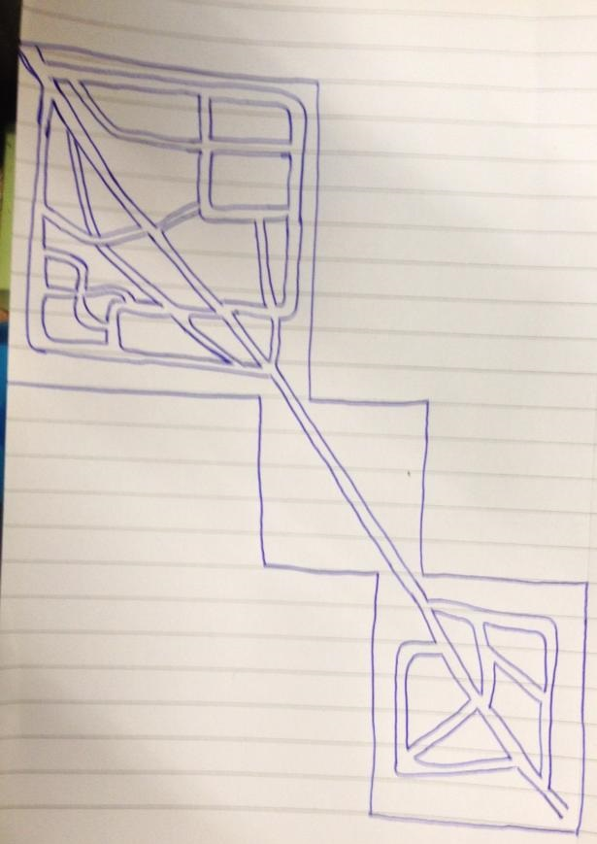

The map represents a simple and basic layout of the city. The lower district is at the top right, the high street in the middle and the upper class district at the bottom. All districts are connected via one main road and can’t be accessed otherwise unless by foot.

**Prop List**

The following list shows some of the props that the player may find whilst roaming the city:

Bins



Here are two different types of bins that will be used on the left is the larger dumpster bin that would be found is some alley ways, backs of supermarkets and stores and maybe some higher end residential areas. On the right are wheelie bins which are the common bins that are used in middle class and lower class residential areas, these bins will be placed around the lower class area of the game.

Mansion

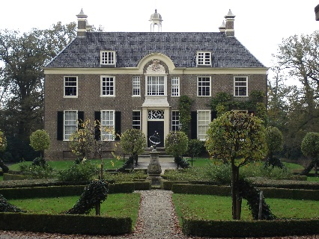

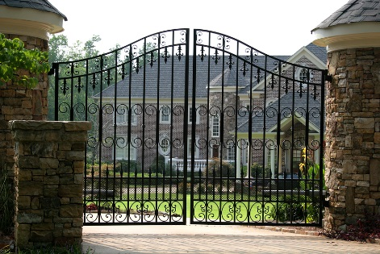

A mansion like this will be where the main antagonist of the game will reside. This type of mansion was chosen for its British countryside look which the upper class area will be like, the gates will be at the front of the mansion to secure the area and stop the player from entering until given the opportunity later in the game. The mansion will be placed at the top right within the upper class district of the map.

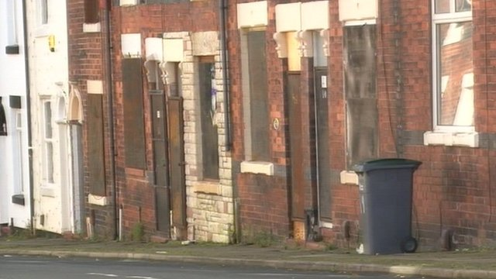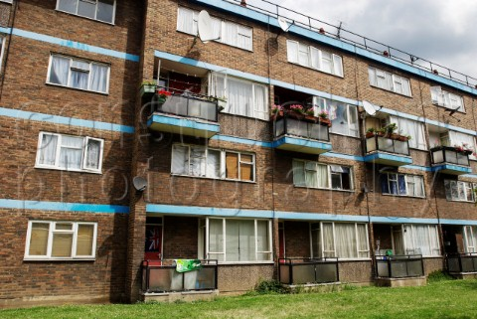Houses (lower-class district)

These are the types of houses and flats that would be found all around the lower district of the map; mostly in rows along the street and block of flats. The houses will fill up the most of the lower district as it is a residential area.

Usable Cars

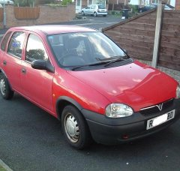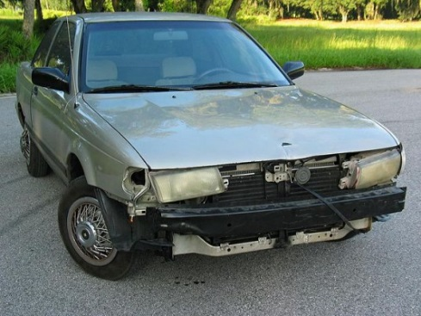

In terms of transport the player will have access to two types of cars throughout the game, the car on the left will what the player starts with, a very unreliable car. If the player manages to get far enough they will have the ability to upgrade their vehicle to a common middle class car which will reflect the image on the right.

Pay Points

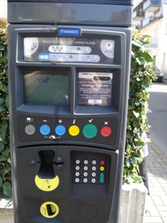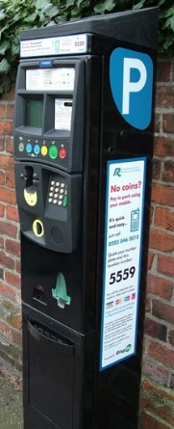

These types of parking meters are what would be found all over the parking lot which will be placed at the corner of the high street.

Mansion Pool

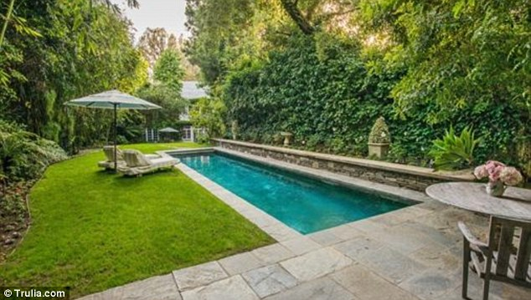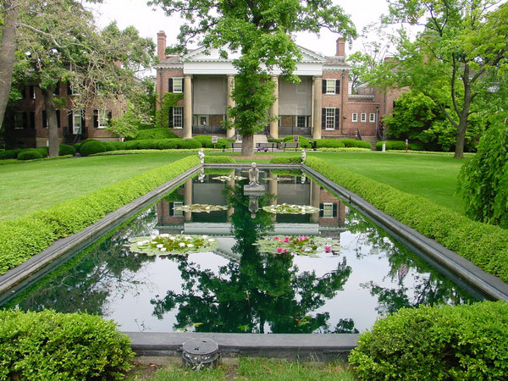

At the back of the mansion that’s placed in the upper district there will be a garden that will contain a pool. The two pools are both British made house pools that both support the same rectangular shape.

Park Bench



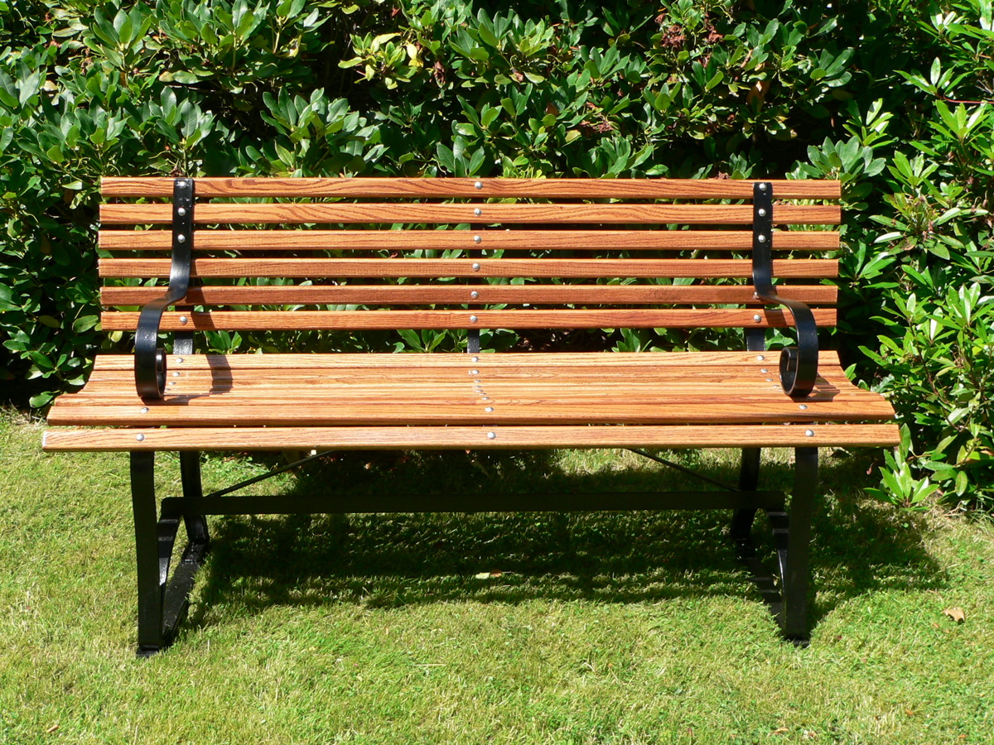

The game will have two different types of parks, one being in the upper district and the other being in the lower, the parks will both have benches but of two different types. The bench on the left will be placed in the upper district park and the one on the right in the lower district.

Playground

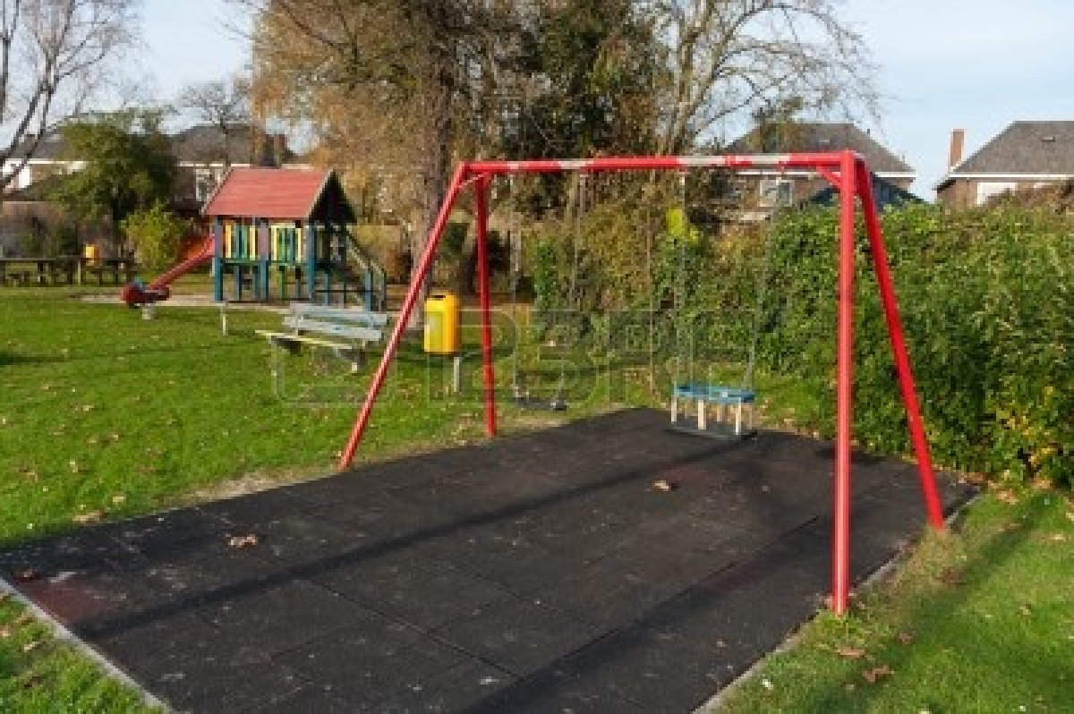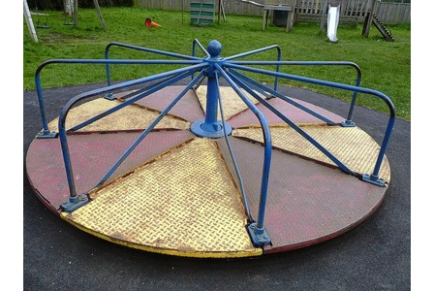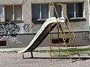

Within the lower district there will also be an old “shady” playground, the slide roundabout and swing set will make up the playground.

Plaza

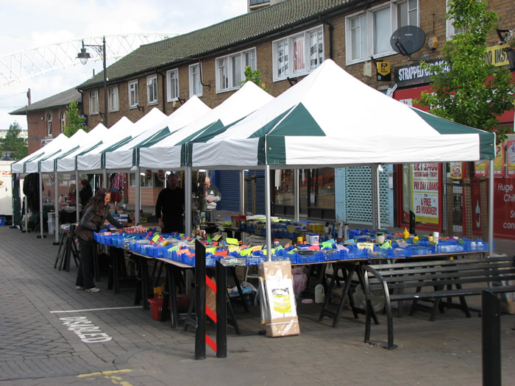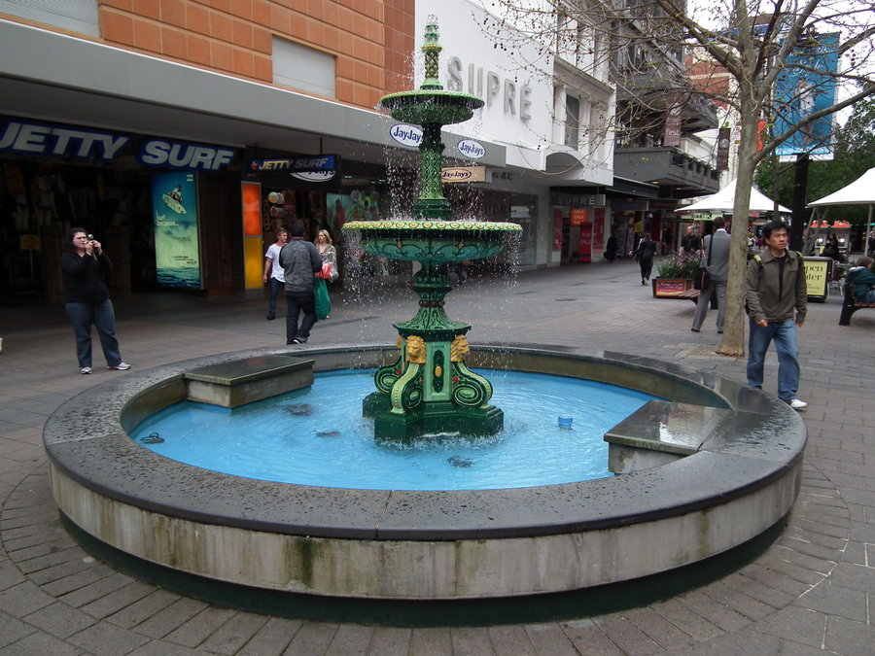

The high street will be made up of many shops almost like an outdoor mall, the fountain will be a centrepiece for the high street and the market stalls would also be placed around the high street. The market stall could make for a gateway into stealing.

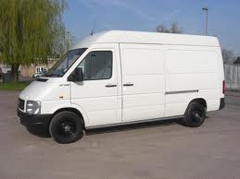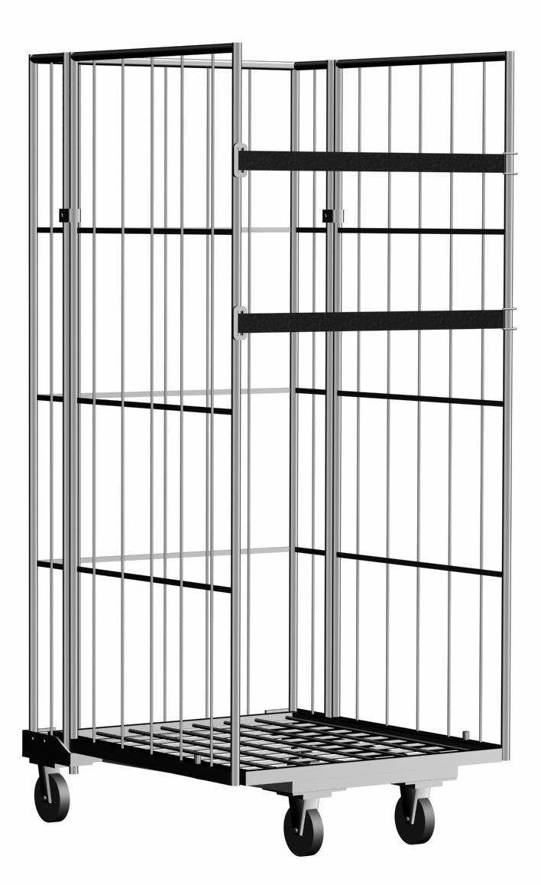Extras

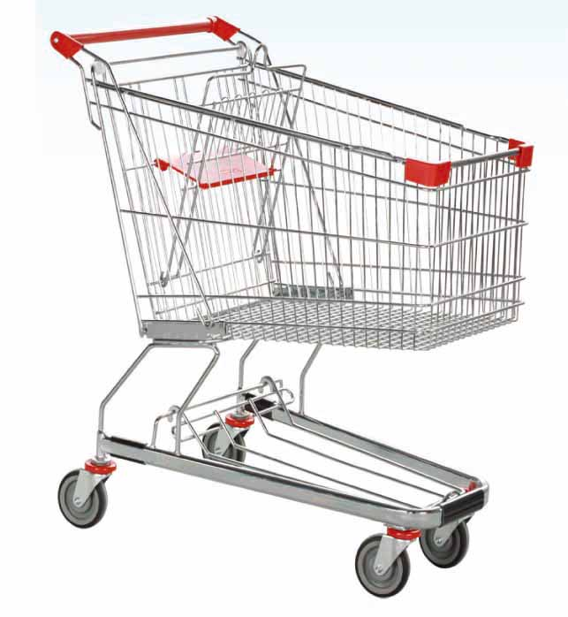

The extra items here are construction cones supermarket cages and trollies and white delivery vans. The cones could be placed within the lower district and high street, where as the other three will mostly only be found around the high street near supermarkets.

*Sounds:*

The following is a list of all audio tracks needed for the game.

* Car ambient
* Walking
* Running
* Gun fire
* Knife slash
* Ambient city backing music
* Fast paced action backing music
* Police cars
* Email Notification
* Add money notification
* Spend money notification
* Menu selection noises